Staff Bio-data
- Personal Information
Name of Faculty: | Mr. Rajendra Anandrao Patil |  |  | 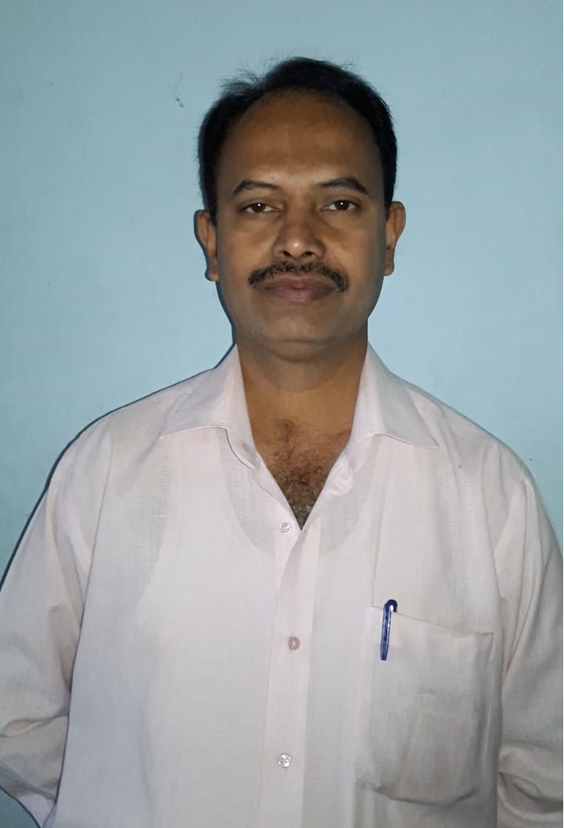
Designation: | Technical Lab Assistant
Department: | Basic Science and Humanities
Date of Birth: | 20/05/1973 | Date of Joining: | 1.Institute Joining: 16/11/1994  2. College joining: 16/12/2006
Qualification: | ITI Electrician, NCTVT, & B.A. ( Arts)
Area of Specialization: | Electrical, Counseling, Marathi  ( Literature)
Total Experience: | 29 Years
Mobile No: | 9922137585
E-mail ID: | rajendra.patil@kbpcoes.edu.in
Address: | Kalptaru Apartment, Flat. No. 02, Pirwadi Road, Visava Park, Satara-415003

- Awards/Recognition Received: “गुणवंत रयत सेवक पुरस्कार-2022”
(“Gunwant Rayat Sevak Award-2022” given by Rayat Shikshan Sanstha, Satara.
- Consultancy Activities: Electrical Consultancy

